This plugin operates on the Smart Client and its purpose is to enable the user to post-search in the recorded analytics data.

## Install

Create a folder in C:\Program Files\Milestone\MIPPlugins and put the compiled files there. Restart the Smart Client.

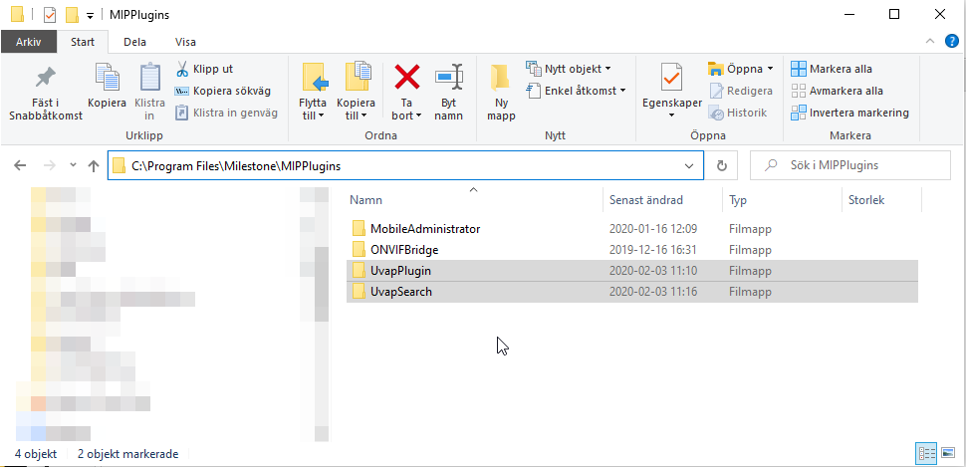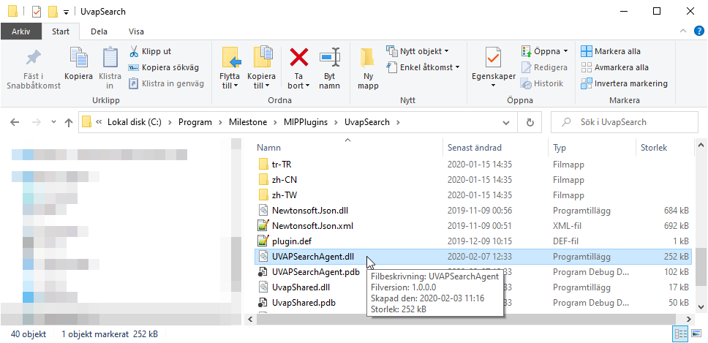

Note: The metadata channel must be related to the camera for this plugin to work. In the Management client, go to Cameras, select the camera, go to the Client tab and select the related metadata channels. This is covered in the driver document.

## Usage

1. Log in to the Milestone server with the Smart Client
2. Go to the “Search” tab
3. Select the camera you want to use for the search (Max 1)
4. Presss “Seach for…” and select the search you want to use, then “New search”
5. 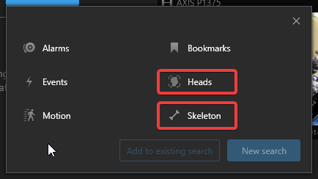Press the filter button

4

1. Edit the settings to your preference
2. 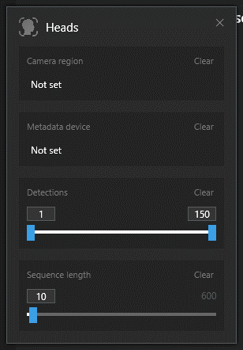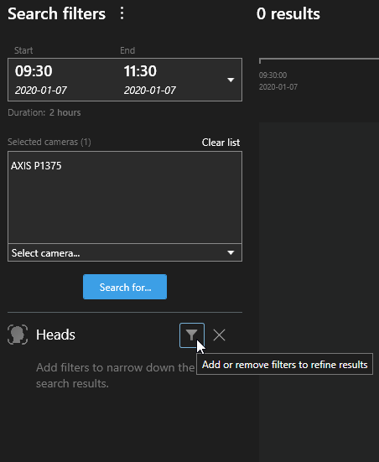View the results

6

5

# Heads search

**Camera region**: The region of interest, results will only be included if they exist within the region. The detection confidence is set here (lower slider).

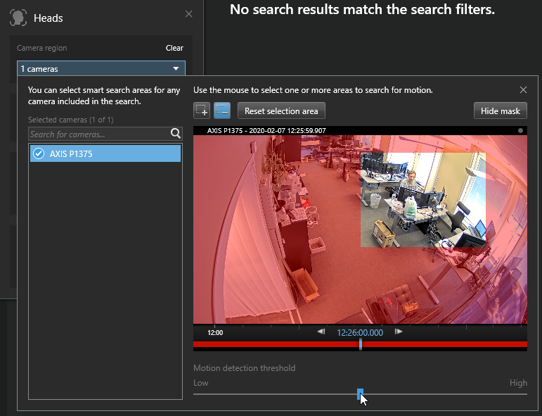

**Metadata device**: The metadata channel containing the analytics data

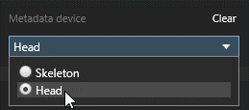

**Detections**: Filter the number of heads in the ROI to be included in the results

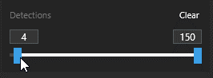

*In this case we will only get results if the number of heads in the selected camera region is between 4 and 150.*

**Sequence length** (optional): X number of seconds to skip between returned sequences

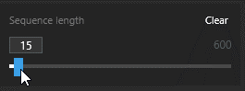

*In this case we will only get one result every 15th second to avoid doubles in the results screen.*

# Skeleton search

**Camera region**: The region of interest, results will only be included if they exist within the region. The detection confidence is set here (lower slider).

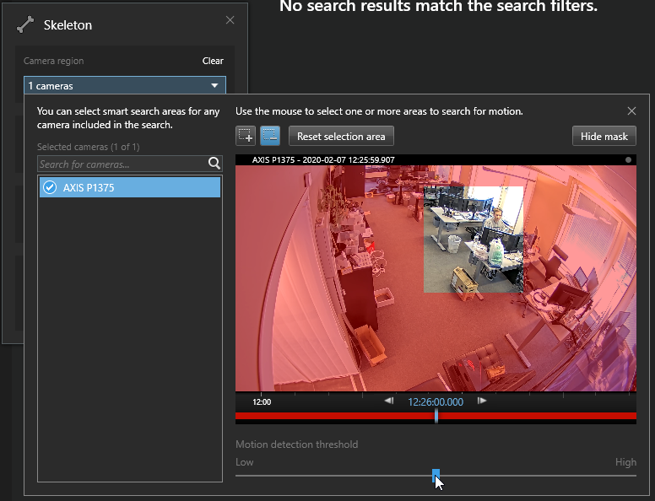

**Skeleton type**: The types of skeleton points to search for

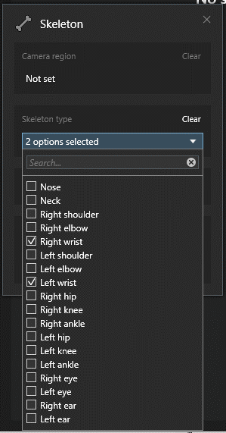 *In this case we will only get results if either a right wrist or left wrist is visible within the selected camera region.*

**Metadata device**: The metadata channel containing the analytics data

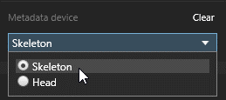

**Sequence length** (optional): X number of seconds to skip between returned sequences



*In this case we will only get one result every 15th second to avoid doubles in the results screen.*

# Results

When the search filters are filled the main screen will be populated with the potential search results. If any search result is selected, the panel on the right side will display the selected search result.

Heads search result:

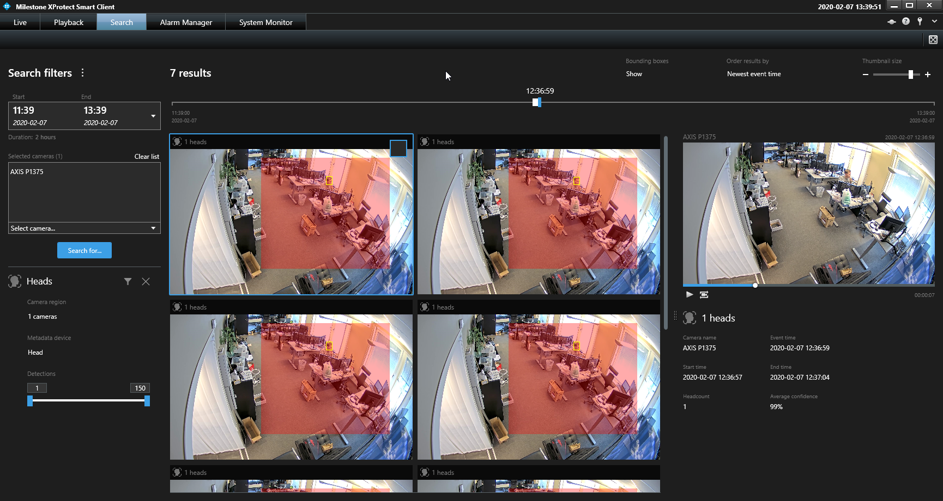

Skeleton search result:

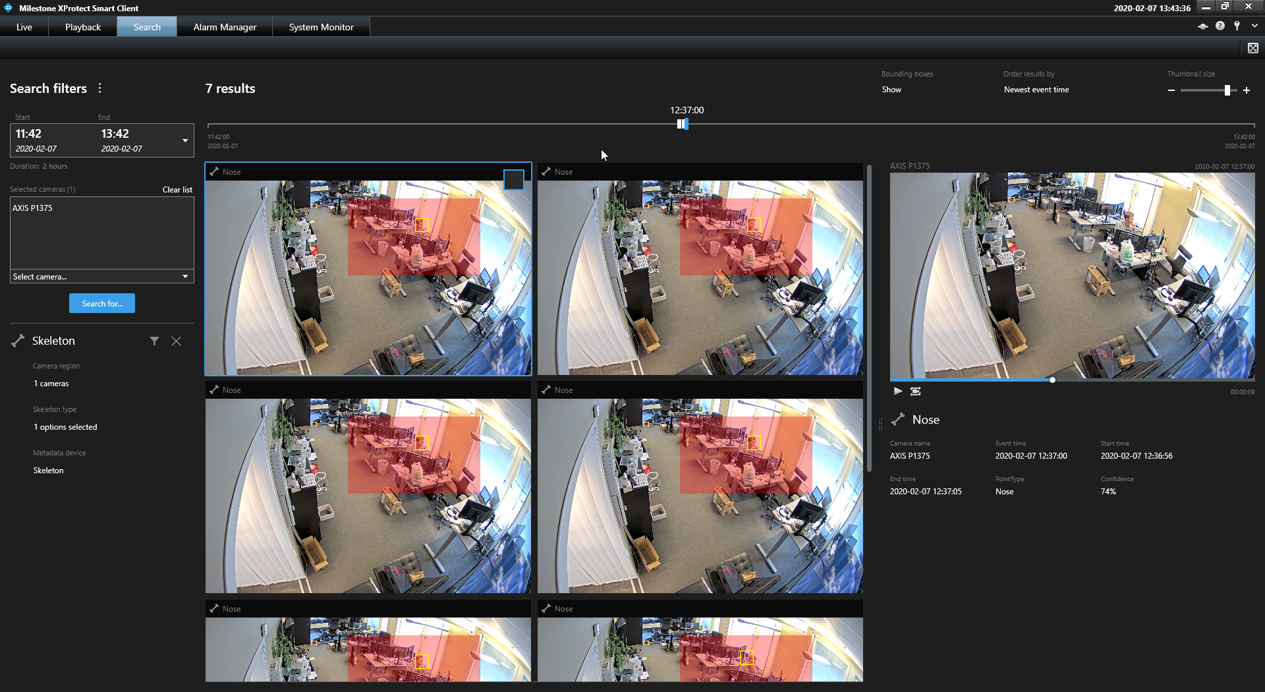

Each search result will display the search hit (yellow rectangle) and selected camera region (red area). The yellow rectangle can represent detected heads or a skeleton point.

Left: One head is detected and highlighted with a bounding box.

Right: A nose is detected and is highlighted with a bounding box.

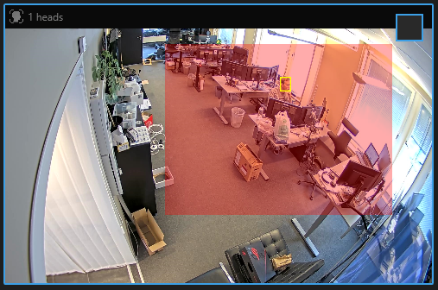 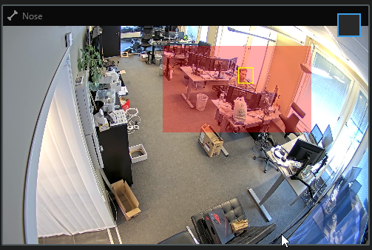

# Dependencies

.NET Framework 4.7 or later (Requires install) <https://dotnet.microsoft.com/>

Newtonsoft.Json 12.0.3 (Included in build) <https://www.newtonsoft.com/json>